IMPORTANT – PLEASE BECOME AN OBSERVER OF YOUR
STUDENT’S CANVAS PAGE THIS WEEKEND!!
PARENT of ______________________________ August 16, 2021
If you are receiving this sheet, you are still not observing your student’s Canvas page. This is making it impossible for you keep up with everything we have going on in class, including assignments, resources, pictures, projects, and our class calendar.
This is multi-step process so take it step-by-step and you will be signed up in 5 minutes.
First, you will need to know your student’s login information once they get to the Paulding County School website and the Canvas login screen…
Username:
Password:
Once they login to Canvas, you will need to do the following:
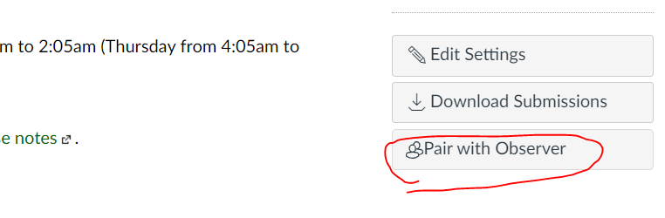
3. On the right hand side of the screen, click “Pair Observer” and write down the code it gives you. You will need this code for the next step.
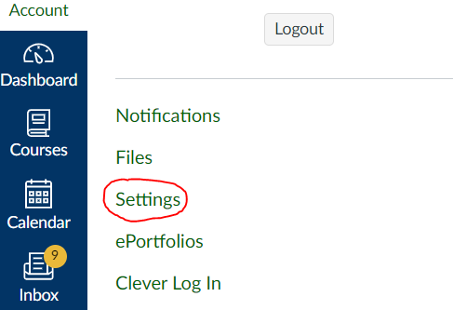
2.Click Settings.
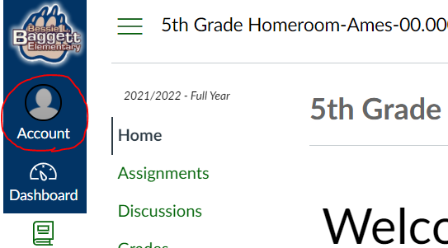
1.Click on the Account button on the top left corner of the screen.

Now, it is time to set up your Parent Observer Account…go to www.paulding.k12.ga.us/canvas
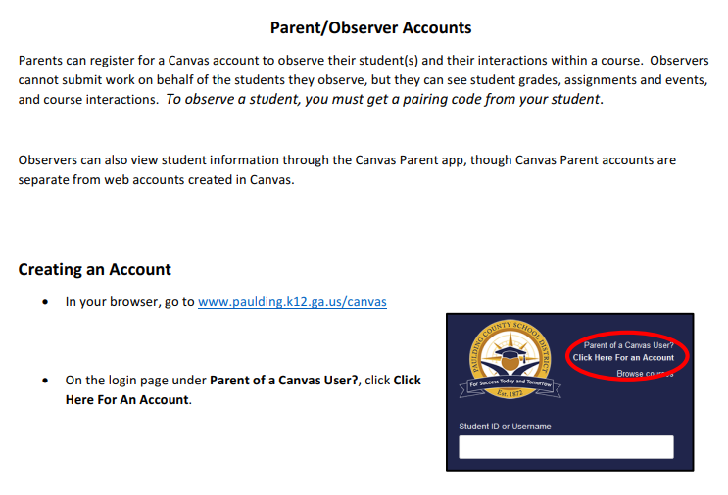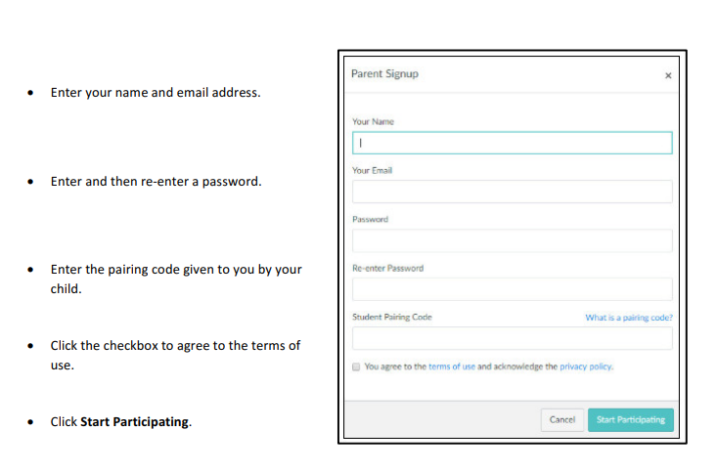

Continue onto the back for The Dashboard and Calendar Features available to you as a Parent Observer. ________________________________________________________________________________________________
Please Sign and Return once you have completed the parent observer sign-up.
Parent Signature:________________________________________ August 16, 2021
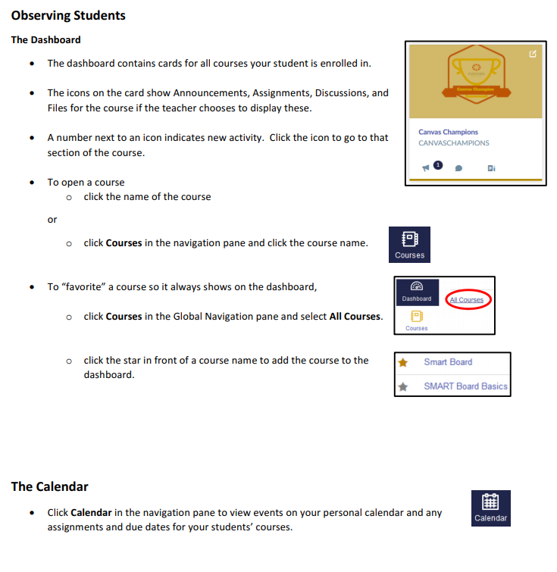_________________________________________________________________________________________________
If you have any trouble signing up or have any questions about it, please let me know below. Thank you so much for your help and support this year on Canvas.

__________________________________________________________________________________________________________________________________________________________________________________________________________________________________________________________________________________________________________________________________________________________________________________________________________________________________________________________________________________________________________

